Description of kNN algorithm

The kNN algorithm is a simple classification algorithm that stores all available examples and classifies new instances of the example based on a similarity measure. It has several important characteristics,
- Examples are described using a vector of numerical attribute-values and symbolic attributes.
- The complete example set is simply stored in the "training phase".
- Calculations are delayed until queries to classify a new data item occur.
- The distance between two example vectors is regarded as a measure for their similarity.
- To classify a new instance e from the set of stored examples, the k examples most similar to e are determined. The new instance is assigned the class that most of these k examples belong to. Generally, each of the k examples issues a weighted vote, where the weight is inversely proportional to its distance to e.
- Note that there is no "training" as such for this classifier, i.e., it just takes a training data set and uses it as a "memory" for classifying new feature vectors.
A major problem of k-NEAREST NEIGHBOR is to define a proper distance metric. The vector distance will not necessarily be suited for finding intuitively similar examples, especially if irrelevant attributes are present. How to find optimal distance metrics for each real-world data set is still an open research topic. In our assignment, we simply use the Euclidean distance to define "closeness" between two vectors, i.e. 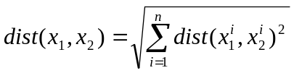, where the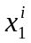 and 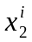 is the i^{th} attribute in two vectors 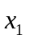and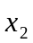. The distance between two symbolic attributes is defined in the similar matrix. The distance between two continuous attributes is the scaled difference between two values, i.e. 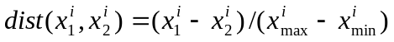, where 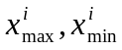 is the maximum and minimum value for the i^{th} attribute in the training set.

A variant of this approach is suited for function approximation as well. Instead of assigning the most frequent classification among the k examples most similar to an instance e, an average of the function values of the k examples is calculated as the prediction for the function value e.

